10/7/2026
Instructor: Sir Hairs
Submitted by: Wasif Ali
Reg id: 245187
Class: BSCS F24 B


Assignment No 01
Full-Stack Development Lab
Assignment no 01

XAMPP Control Panel:
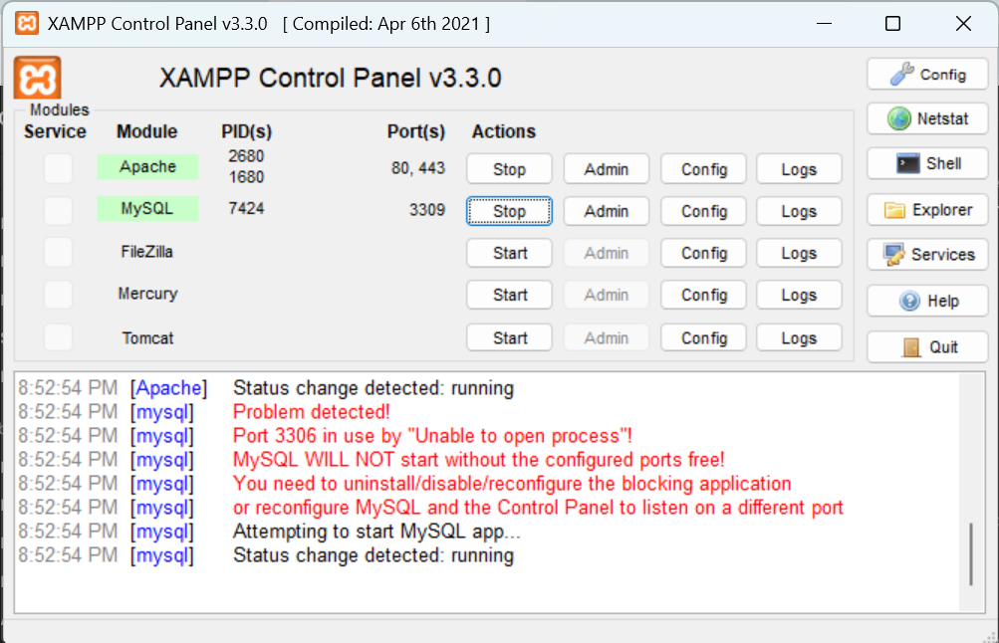

Server running
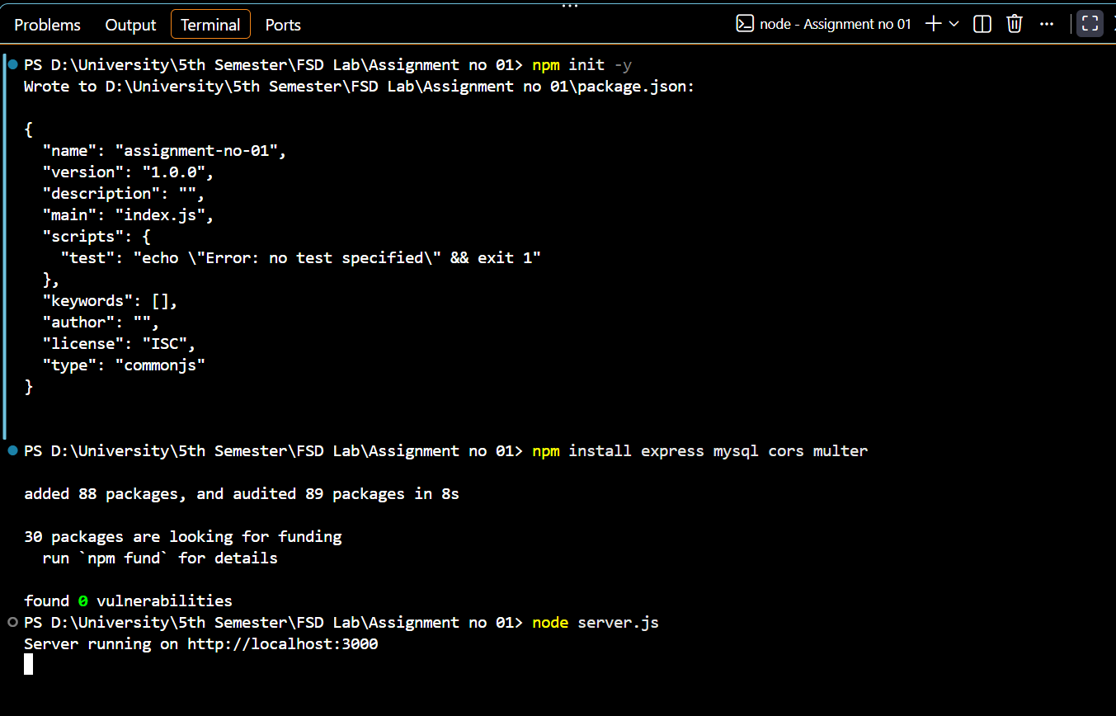
PhpMyAdmin
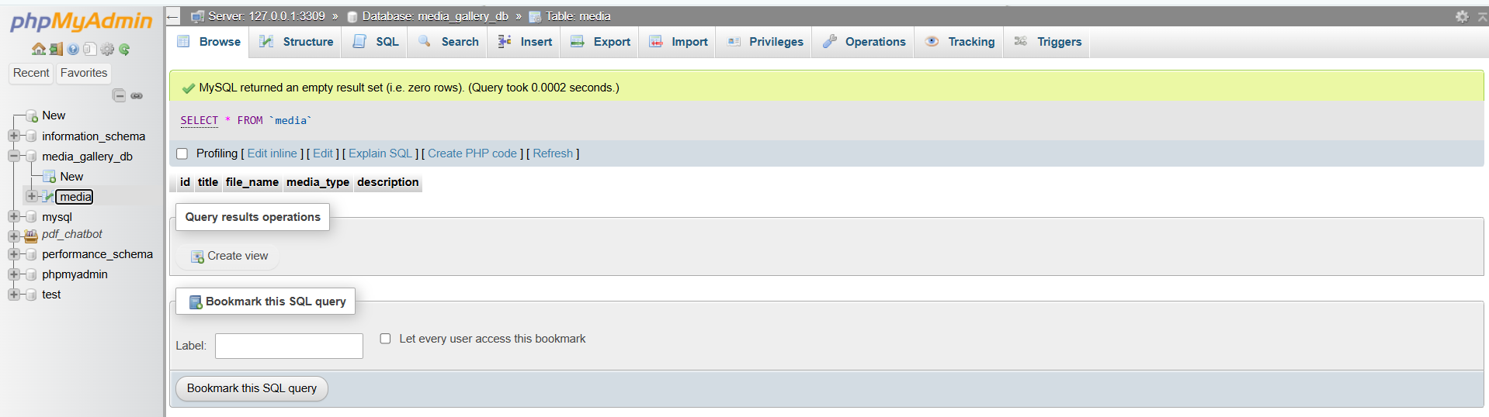

Frontend
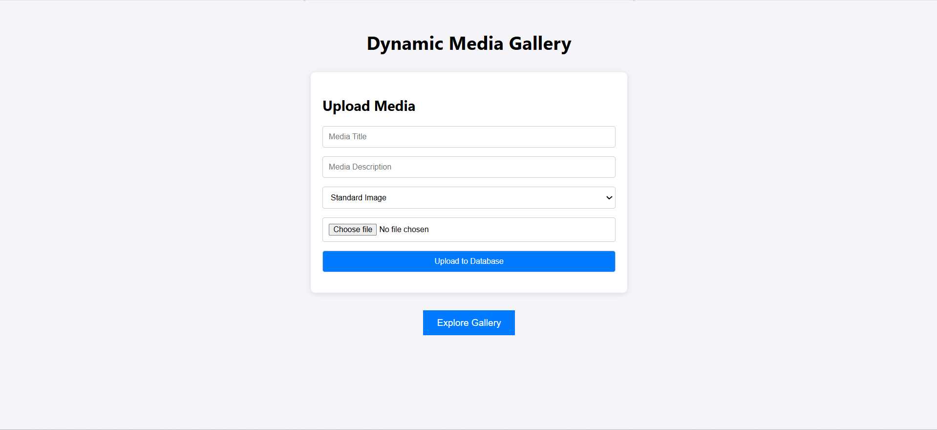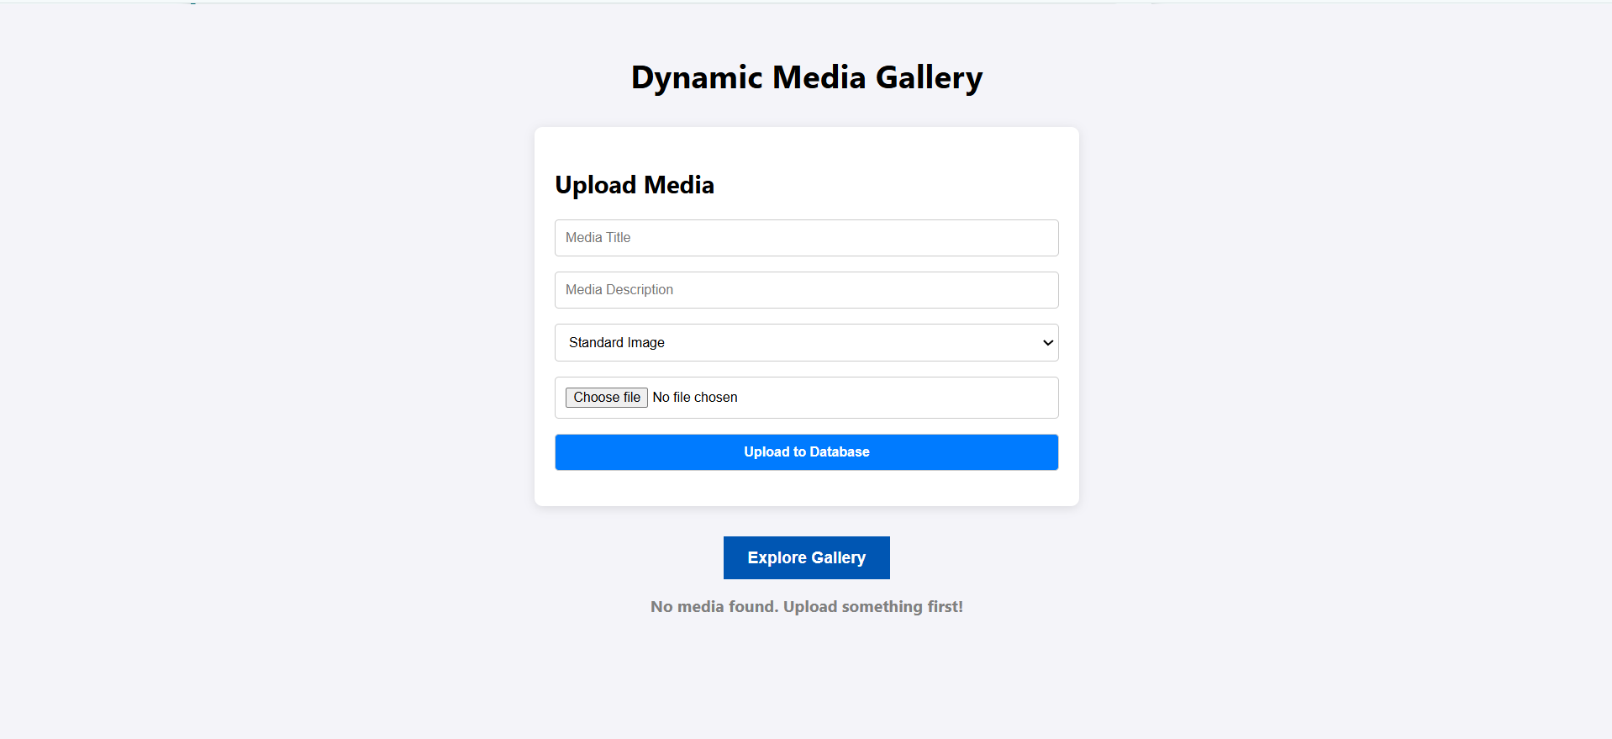
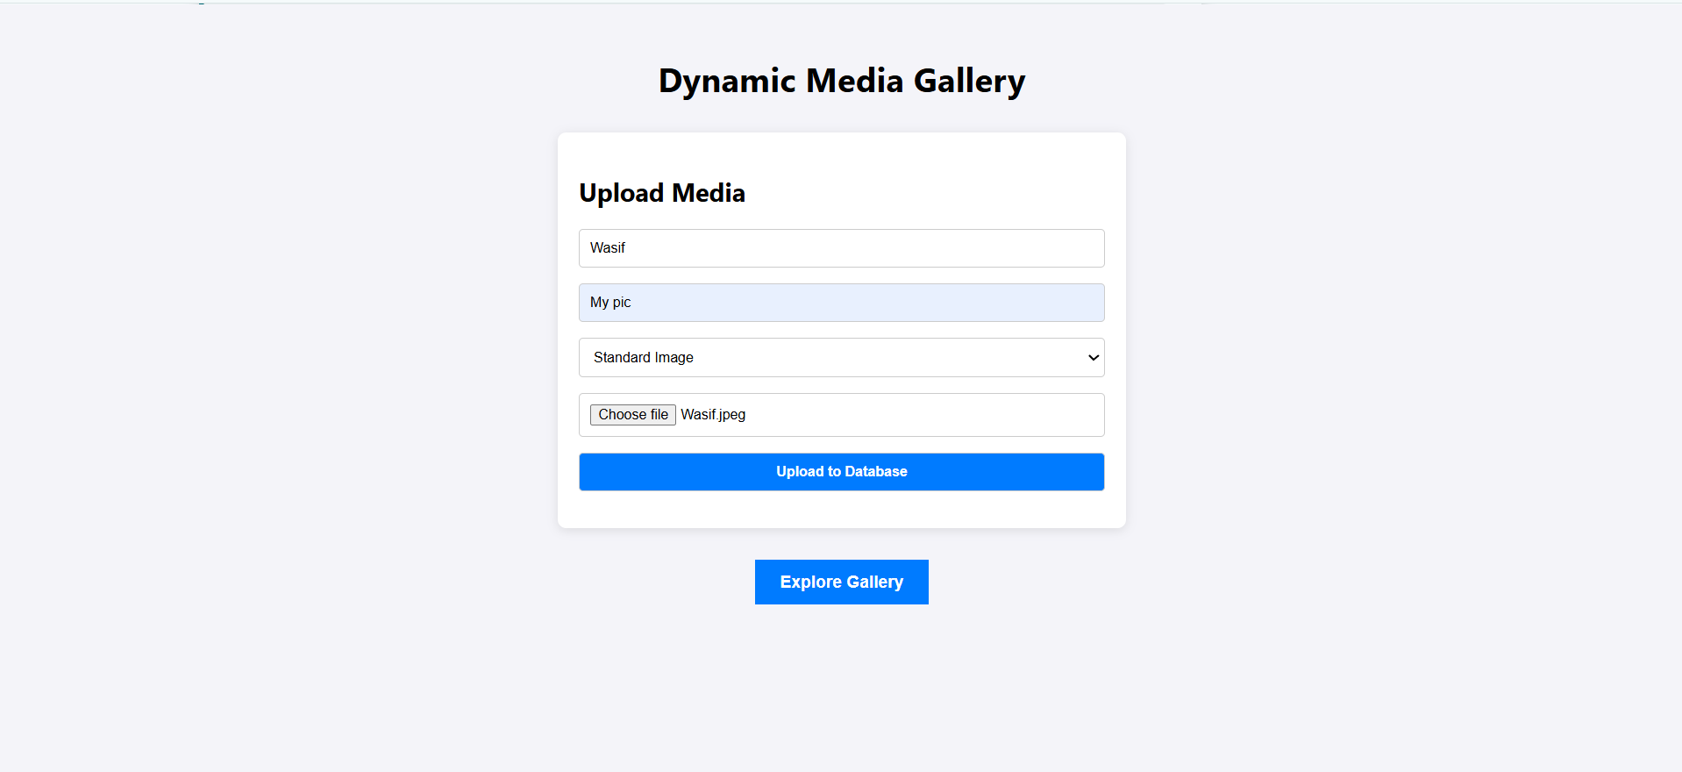
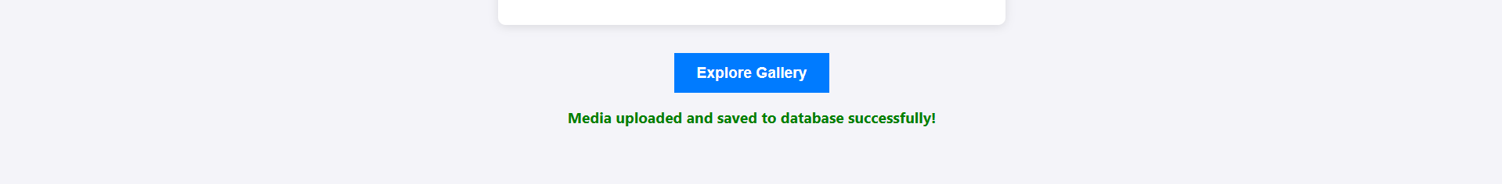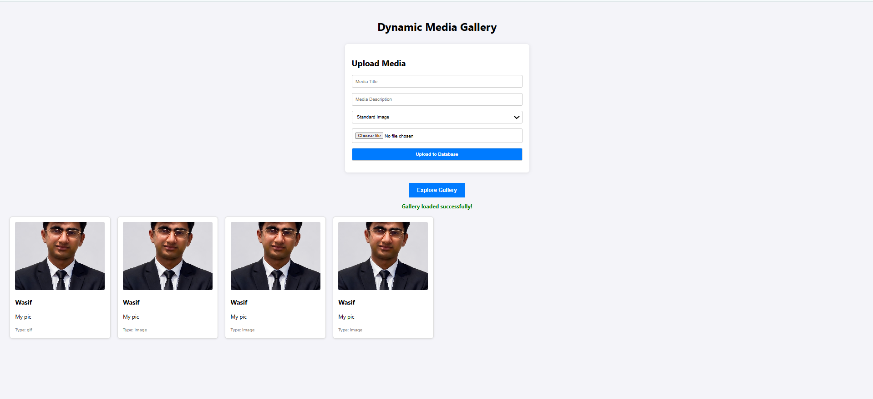

Server.js
const express = require('express');
const mysql = require('mysql');
const cors = require('cors');
const multer = require('multer');
const path = require('path');

const app = express();
const port = 3000;

// Middleware
app.use(cors()); // Allows the front-end to communicate with this API
app.use(express.json());
app.use(express.urlencoded({ extended: true }));

// Expose the uploads folder so the front-end can display the images/GIFs
app.use('/uploads', express.static(path.join(__dirname, 'public/uploads')));

// 1. Database Connection Pool
const con = mysql.createPool({
host: "localhost",
user: "root",
password: "",
database: "media_gallery_db",
port: 3309, //
connectionLimit: 10
});

// 2. Configure Multer for File Uploads
const storage = multer.diskStorage({
destination: function (req, file, cb) {
cb(null, 'public/uploads/');
},
filename: function (req, file, cb) {
// Generates a unique filename using the current timestamp
cb(null, Date.now() + path.extname(file.originalname));
}
});
const upload = multer({ storage: storage });

// 3. Upload Route (POST endpoint)
app.post('/upload', upload.single('mediaFile'), (req, res) => {
// Extract text fields from the request body
const { title, media_type, description } = req.body;

// Extract the newly generated filename from multer
const file_name = req.file.filename;

// Insert the record into MySQL securely using placeholders
const sql = "INSERT INTO media (title, file_name, media_type, description) VALUES (?, ?, ?, ?)";

con.query(sql, [title, file_name, media_type, description], (err, result) => {
if (err) {
console.error(err);
return res.status(500).json({ message: "Database Error" });
}
res.status(200).json({ message: "Media uploaded and saved to database successfully!" });
});
});

// 4. GET Endpoint for jQuery AJAX
app.get('/media', (req, res) => {
// Fetch all records, newest first
const sql = "SELECT * FROM media ORDER BY id DESC";

con.query(sql, function (err, result) {
if (err) {
console.error(err);
return res.status(500).json({ message: "Database Error" });
}
// Returns the database records as a JSON array to the browser
res.json(result);
});
});

// Start the server
app.listen(port, () => {
console.log(`Server running on http://localhost:${port}`);
});

Index.html
<!DOCTYPE html>
<html lang="en">

<head>
<meta charset="UTF-8">
<title>Dynamic Media Gallery</title>

<!-- Include jQuery CDN -->
<script src="https://code.jquery.com/jquery-3.7.1.min.js"></script>

<style>
body {
font-family: 'Segoe UI', Tahoma, Geneva, Verdana, sans-serif;
padding: 20px;
background-color: #f4f4f9;
}

.header {
text-align: center;
margin-bottom: 30px;
}

.upload-section {
background: white;
padding: 20px;
border-radius: 8px;
box-shadow: 0 2px 10px rgba(0, 0, 0, 0.1);
max-width: 500px;
margin: 0 auto 30px;
}

.upload-section input,
.upload-section select,
.upload-section button {
width: 100%;
margin-bottom: 15px;
padding: 10px;
border: 1px solid #ccc;
border-radius: 4px;
box-sizing: border-box;
}

button {
background-color: #007bff;
color: white;
border: none;
cursor: pointer;
transition: background-color 0.3s;
padding: 10px;
font-weight: bold;
}

button:hover {
background-color: #0056b3;
}

.gallery-grid {
display: grid;
grid-template-columns: repeat(auto-fill, minmax(280px, 1fr));
gap: 20px;
margin-top: 20px;
}

.media-card {
background: white;
border: 1px solid #ddd;
padding: 15px;
border-radius: 8px;
transition: transform 0.3s ease;
box-shadow: 0 2px 5px rgba(0, 0, 0, 0.1);
}

.media-card:hover {
transform: scale(1.05);
}

.media-card img {
width: 100%;
height: 200px;
object-fit: cover;
border-radius: 4px;
}

#status {
text-align: center;
margin: 15px 0;
font-weight: bold;
}
</style>
</head>

<body>

<div class="header">
<h1>Dynamic Media Gallery</h1>
</div>

<div class="upload-section">
<h2>Upload Media</h2>

<form id="uploadForm" enctype="multipart/form-data">

<input type="text" name="title" placeholder="Media Title" required>

<input type="text" name="description" placeholder="Media Description" required>

<select name="media_type">
<option value="image">Standard Image</option>
<option value="gif">Animated GIF</option>
</select>

<input type="file" name="mediaFile" accept="image/*" required>

<button type="submit">Upload to Database</button>

</form>
</div>

<div style="text-align: center;">

<button id="loadMedia" style="padding: 12px 24px; font-size: 16px;">
Explore Gallery
</button>

<div id="status"></div>

</div>

<div id="gallery" class="gallery-grid"></div>

<script>

// Ensure DOM is ready before executing scripts
$(document).ready(function () {

// ---------------------------------------
// 1. Handle File Upload via AJAX
// ---------------------------------------

$('#uploadForm').submit(function (e) {

e.preventDefault();

$('#status')
.html('Uploading...')
.css('color', 'blue');

let formData = new FormData(this);

$.ajax({

url: 'http://localhost:3000/upload',

type: 'POST',

data: formData,

contentType: false,

processData: false,

success: function (response) {

$('#status')
.html(response.message)
.css('color', 'green');

$('#uploadForm')[0].reset();
},

error: function (xhr) {

$('#status')
.html('Upload failed. Check server connection.')
.css('color', 'red');
}

});

});

// ---------------------------------------
// 2. Fetch and Display Gallery via AJAX
// ---------------------------------------

$('#loadMedia').click(function () {

$('#status')
.html('Loading gallery...')
.css('color', 'blue');

$.ajax({

url: 'http://localhost:3000/media',

type: 'GET',

dataType: 'json',

success: function (data) {

$('#status').html('');

$('#gallery').empty();

// Check if there is no media
if (data.length === 0) {

$('#status')
.html('No media found. Upload something first!')
.css('color', 'gray');

return;
}

// Display each media item
$.each(data, function (index, item) {

const card = `
<div class="media-card">

<img
src="http://localhost:3000/uploads/${item.file_name}"
alt="${item.title}"
>

<h3>${item.title}</h3>

<p>${item.description}</p>

<small style="color: gray;">
Type: ${item.media_type}
</small>

</div>
`;

$('#gallery').append(card);

});

$('#status')
.html('Gallery loaded successfully!')
.css('color', 'green');

},

error: function (xhr, status, error) {

$('#status')
.html('Error loading media! Ensure Node.js server is running.')
.css('color', 'red');

console.log(xhr.responseText);
}

});

});

});

</script>

</body>

</html>

